THE SEVEN WONDERS OF THE ANCIENT WORLD
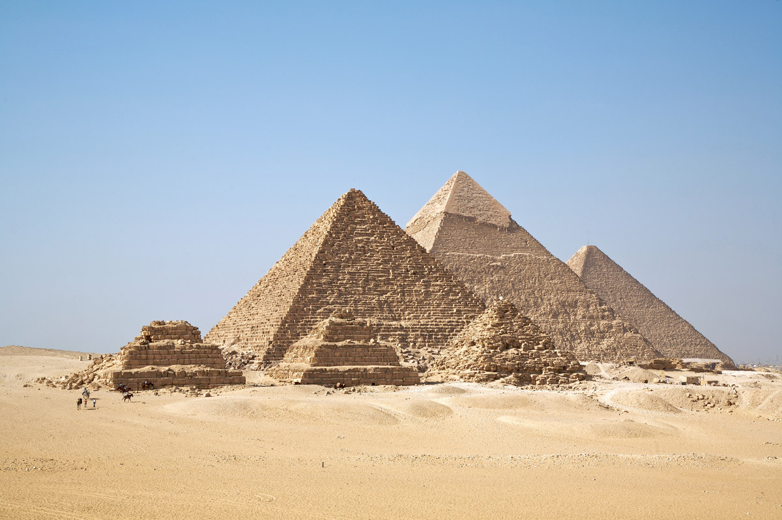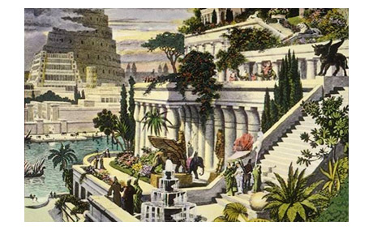
www.famouswonders.com www.fireplacespot.com www.kusadasi.biz

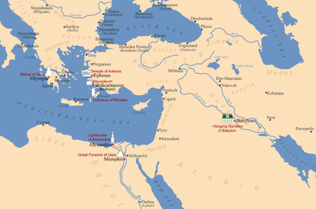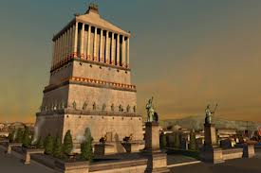
www.famouswonders.com www knowledgeoverflow.com
Rule a line to show the correct location of each structure.

 www.en.wikipedia.org www. blog.beatthebrochure.com 